Assessment Task

Mathematics Methods 1 | Unit 1

Investigation 1 – Graphs and transformations

## Part A: Preparation activities

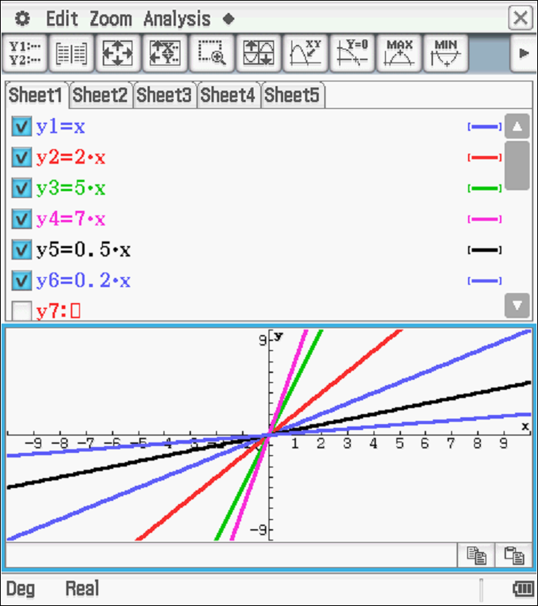**Activity 1:**

(a)

|  |  |  |  |  |
| --- | --- | --- | --- | --- |
| Function | -intercept | -intercept | gradient | in order of steepness |
|  | (0, 0) | (0, 0) | 1 | 3 |
|  | (0, 0) | (0, 0) | 2 | 4 |
|  | (0, 0) | (0, 0) | 5 | 5 |
|  | (0, 0) | (0, 0) | 7 | 6 |
|  | (0, 0) | (0, 0) | 0.5 | 2 |
|  | (0, 0) | (0, 0) | 0.2 | 1 |

* The greater the gradient the steeper the line.
* The greater the gradient the closer the line is to the -axis.

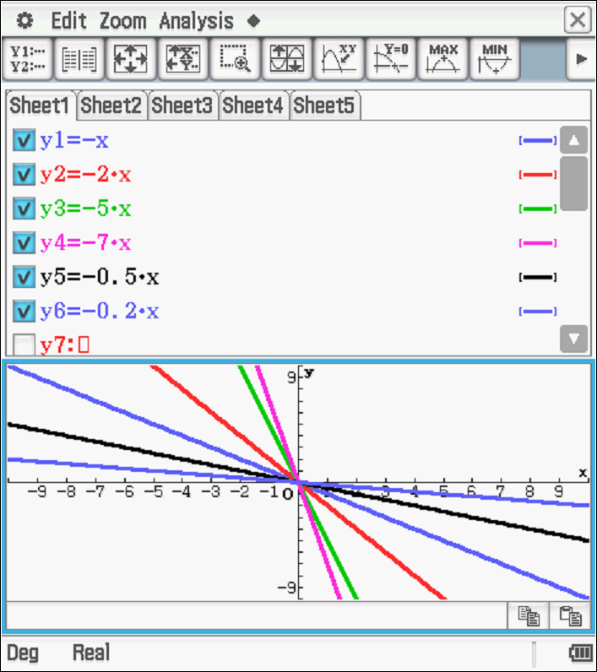(b)

|  |  |  |  |  |
| --- | --- | --- | --- | --- |
| Function | -intercept | -intercept | gradient | in order of steepness |
|  | (0, 0) | (0, 0) | -1 | 3 |
|  | (0, 0) | (0, 0) | -2 | 4 |
|  | (0, 0) | (0, 0) | -5 | 5 |
|  | (0, 0) | (0, 0) | -7 | 6 |
|  | (0, 0) | (0, 0) | -0.5 | 2 |
|  | (0, 0) | (0, 0) | -0.2 | 1 |

* The smaller the gradient value the steeper the line.
* The smaller the gradient value the closer the line is to the -axis.
* No. It is not true to say ‘The higher the gradient, the steeper the line’.
* All of these statements are influenced by the negative sign.
* If the negative sign is ignored then the steepness is a measure of the size of the number.
* As  varies, the change to the corresponding -values determines the steepness; the greater this change in the -value, the higher the gradient (ignoring the negative) and the steeper the line.

1. (i) The line has been reflected over a line. All points on the image are as far from the  
   -axis as the corresponding points of the original object.

(ii) The -axis.

(iii) Yes.  is always a reflection of. Each point  becomes .

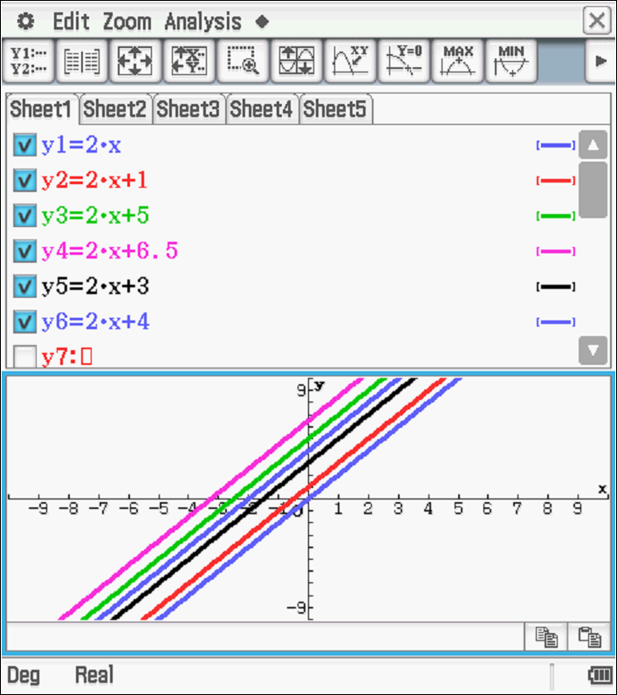

(d) (i) In the rules a number is added, and in the graph

the lines are parallel to each other, but moved up

the -axis relative to the number added.

(ii) The graphs would be moved down the from the

origin by the number subtracted.

(iii)  is parallel (has the same slope) as

 but has been moved (translated)

4 units vertically upwards.

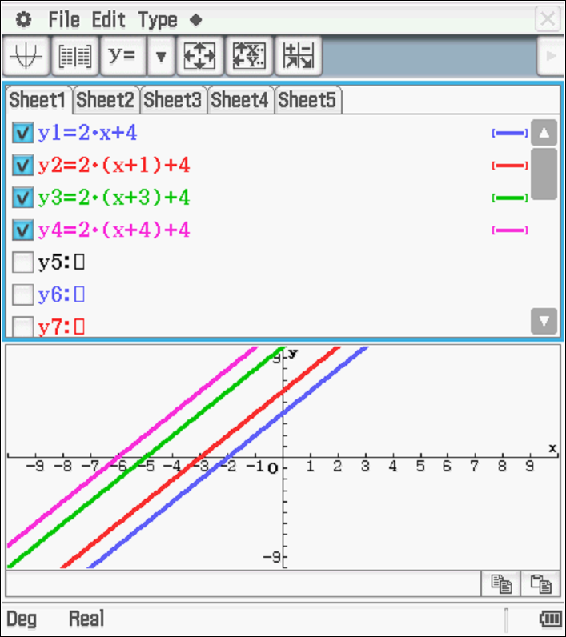(e) (i) A translation is a movement of the figure.

The figure changes position but retains its size

and shape.

The graph of is 1 unit to the left   
 of.

(ii) All lines with the general rule 

wherehave the same gradient. The   
 coefficient ofis unchanged.

The -intercept for these lines is (0, 2*a* +4)

The -intercept for these lines is (-*a*-2, 0)

As  increases the line moves left.

(iii)



Compared to the graph of, these graphs will be to the right. The greater the value of  the further they will have been translated to the right.

1.  . Check by drawing the graph on a calculator.

(f) (i) 

(ii) 

(iii) 

**Activity 2: Quadratic relationships**

|  |  |
| --- | --- |
| (a)    (b)  (i) When  > 1, sides of the parabola are steeper than for  (ii) When , sides are not as steep and the graph appears wider than . | (c)     1. When is multiplied by -1, the graph of is reflected over the *x*-axis |

(e)

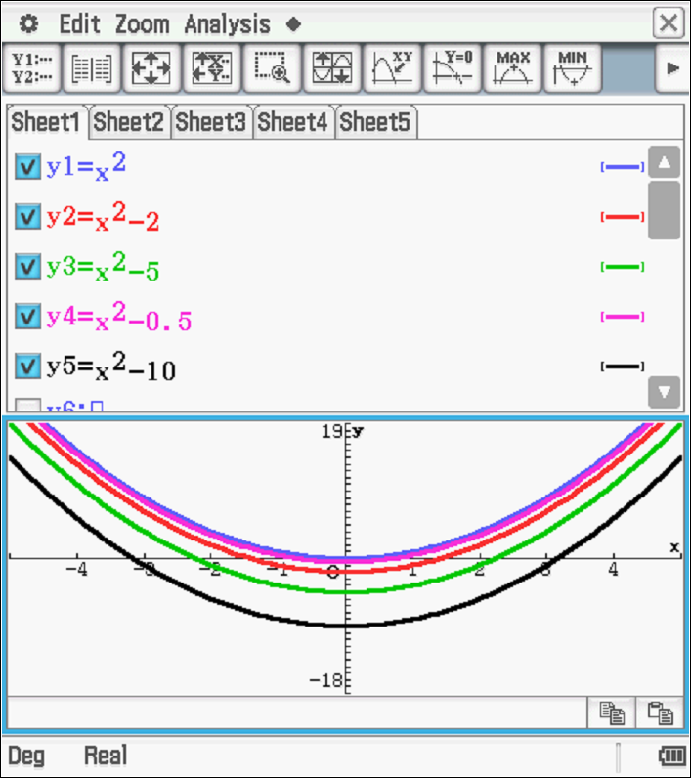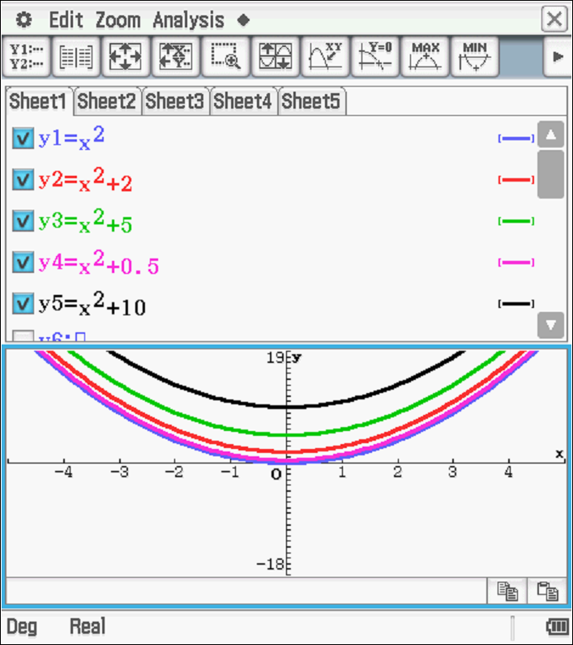

(f) If >0 then the turning point is above the -axis line, if <0 then the turning point is below the -axis and if =0 then the turning point is on the -axis. Note: this is not true for all quadratics but holds if the function has the form .

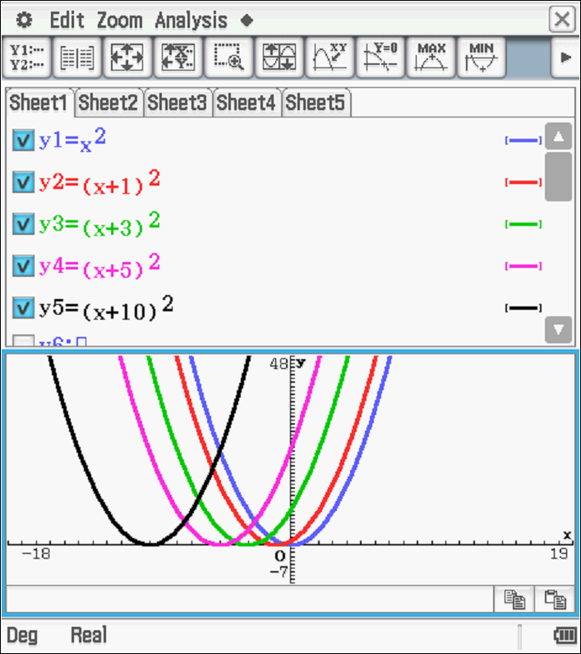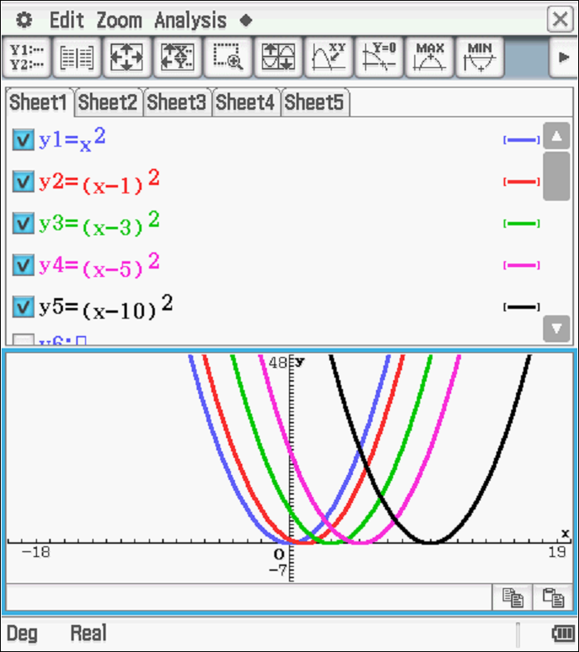(g)

(h)

|  |  |  |  |  |
| --- | --- | --- | --- | --- |
| Function | turning point | -intercept | line of symmetry | -intercept |
|  | (0, 0) | (0, 0) |  | (0, 0) |
|  | (1, 0) | (1, 0) |  | (0, 1) |
|  | (3, 0) | (3, 0) |  | (0, 9) |
|  | (5, 0) | (5, 0) |  | (0, 25) |
|  | (10, 0) | (10, 0) |  | (0, 100) |
|  | (-1, 0) | (-1, 0) |  | (0, 1) |
|  | (-3, 0) | (-3, 0) |  | (0, 9) |
|  | (-5, 0) | (-5, 0) |  | (0, 25) |
|  | (-10, 0) | (-10, 0) |  | (0, 100) |

(i) Graphs of the function , as  varies

(i) As  increases the graph moves horizontally left by the number of units that *k* increases, and the turning point stays left of the -axis while >0. When <0, the turning point is right of the -axis, and as  decreases the graph moves horizontally right by the number of units that *k* decreases.

(ii) are all congruent

(iii) the turning point and the -intercept are both (-*k*, 0), the line of symmetry has the equation and the -intercept is (0, *k*2)

**Activity 3: Transformations**

(a) (i)  (ii)  (iii)  (iv)  (v) 

(b) (i)  (ii)  (iii)  (iv) 

(c) (i)  (ii)  (iii)  (iv) 

(d) (i)  (ii) 

**Activity 4**

The changes to the rules for these functions necessary to produce the required changes to their graphs are

(a) reflect the graph over the -axis, multiply the function by -1   
i.e. to reflect  about the -axis, the function becomes 

(b) translate the graph vertically by *m* units, add *m* to the function  
i.e.  becomes 

(c) translate the graph horizontally by *m* units, replace the  in the rule with   
i.e.  becomes 

(d) increase the steepness of the graph, multiply the function by a number larger than 1 or smaller than -1  
i.e.  becomes where  or .

## Part B: In-class validation

**\*Note:** *Each item has been classified as Simple(S) or Complex(C) to provide teachers with some indication of the anticipated difficulty which may be helpful with grading. However, it must be recognised that the classifications have been provided* ***a priori*** *and will need refining once the tasks have been administered (that is after evidence as to the effect has been gathered).*

**Question 1 (13 marks)**

(a)

|  |  |  |  |
| --- | --- | --- | --- |
| **Solution** | | | |
| (i) a 1 unit horizontal translation to the left (i.e. horizontal shift of -1)  (ii) a 3 unit horizontal translation to the right (i.e. horizontal shift of +3)  (iii) , hence a reflection of  about the -axis followed by a horizontal translation of 2 units to the right will give the required result. | | | |
| **Marking key** | | | |
|  | **Behaviours** | **Marks** | **Item\***  **(S/C)** |
| (i) | States the correct translation giving size and direction | 1 | S |
| (ii) | States the correct translation giving size and direction | 1 | S |
| (iii) | Indicates the reflection about the-axis  States the correct translation giving size and direction | 1  1 | C  C |

(b)

|  |  |  |  |  |  |  |
| --- | --- | --- | --- | --- | --- | --- |
| **Solution** | | | | | | |
|  | Functions | is doubled | | is multiplied by -1 | | |
| (i) |  | The line will be steeper  The line will be closer to the *y*-axis | | The line will be reflected in the *x*-axis  The line will now slope from top left to bottom right | | |
| (ii) |  | The line will move units vertically upward | | The line will move 2units vertically downwards | | |
| (iii) |  | The line will move horizontally right by units | | The line will move horizontally left by units | | |
| **Marking key** | | | | | | |
|  | **Behaviours** | | **Behaviours** | | **Marks** | **Item\***  **(S/C)** |
| (i) | States correct change of gradient | | Identifies line is reflected  Identifies line of reflection | | 3 | S |
| (ii) | Recognises translation is vertical  Translates in correct directions | | Identifies correct number of units in each case | | 3 | S |
| (iii) | Recognises translation is horizontal Translates in the correct directions | | Identifies correct number of units in each case | | 3 | C |

**Question 2 (8 marks)**

|  |  |  |  |  |
| --- | --- | --- | --- | --- |
|  | **Solution** | **Behaviours** | **Marks** | **Item\***  **(S/C)** |
| (a) | (2, 14) | Keeps -value constant  Adds 4 to -value | 1  1 | S  S |
| (b) | (i)  (ii)  (iii) (4, -5) | Draws the correct reflection  States correct equation  Allocates opposite value for  Keeps -coordinate constant | 1  1  1  1 | S  S  S  S |
| (c) |  | Generalises new-coordinate  Keeps-coordinate constant | 1  1 | C  C |

**Question 3 (10 marks)**

**Solution**

1. (b) (c)

(b) (c)

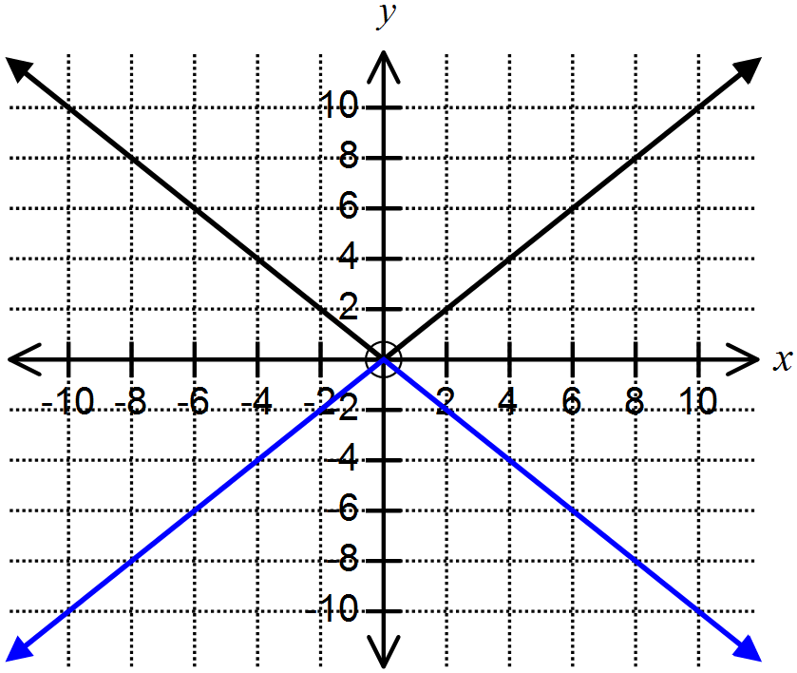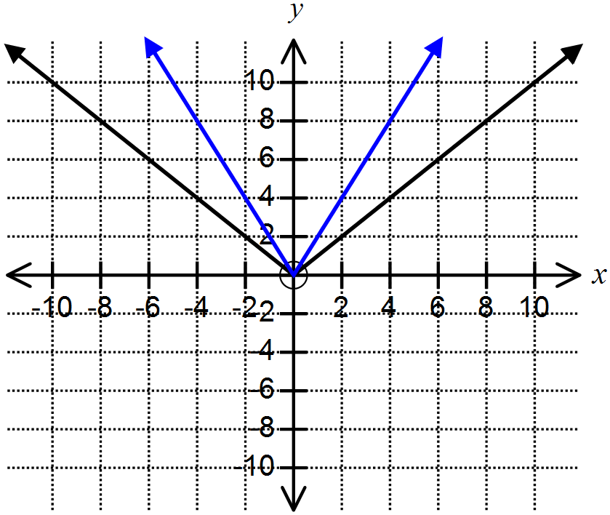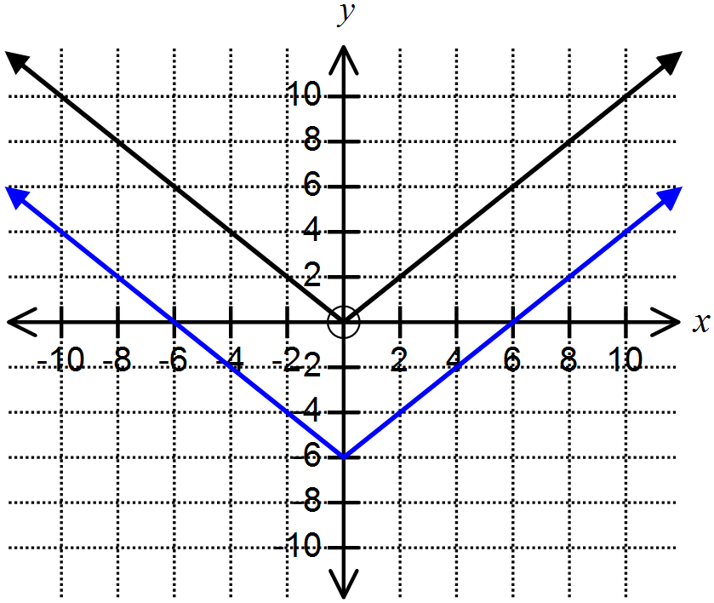

(d) (e) (f)

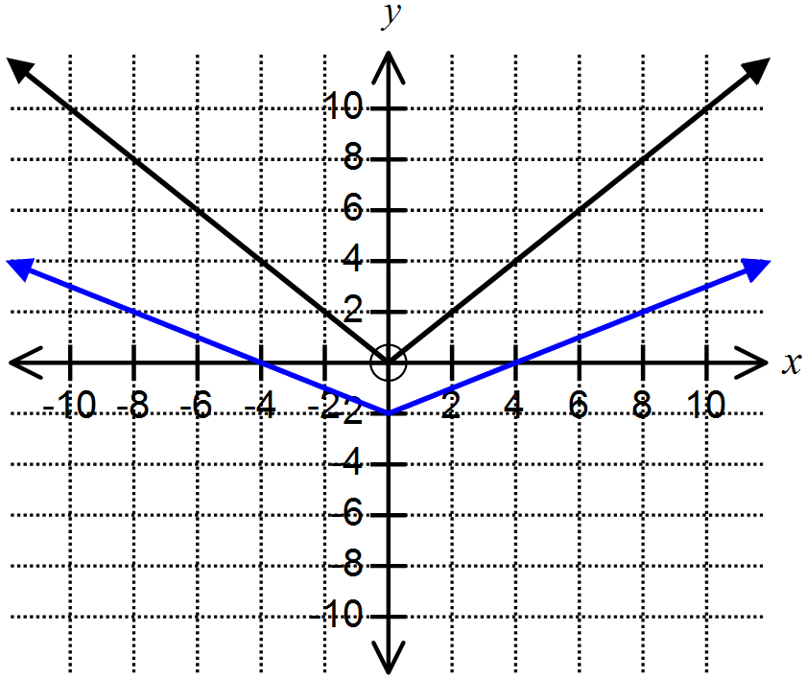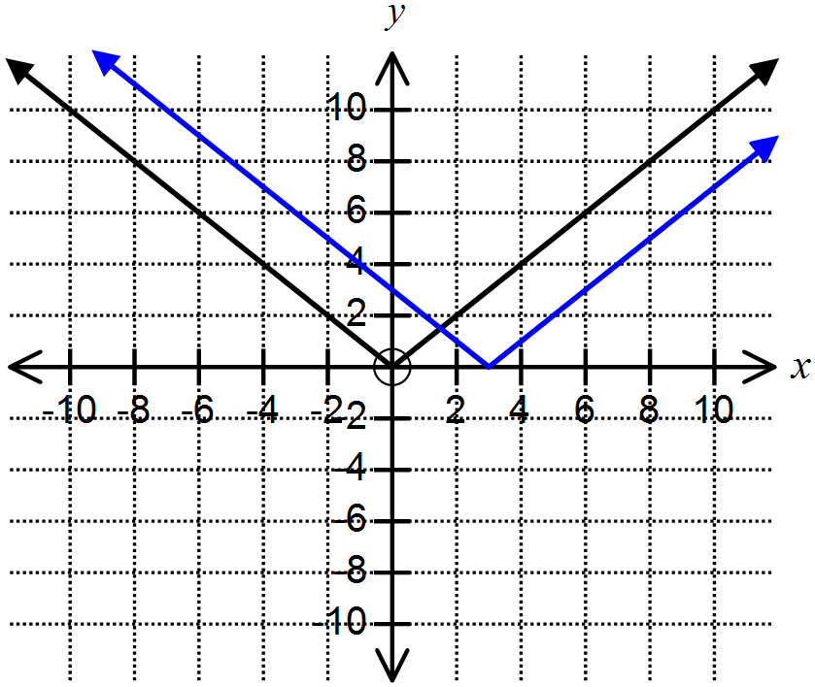

|  |  |  |  |  |
| --- | --- | --- | --- | --- |
|  | **Behaviours**  Function drawn is ... | **Behaviours**  Function drawn is ... | **Marks** | **Item\***  **(S/C)** |
| (a) | congruent | reflected over the -axis | 2 | S |
| (b) | translated down 6 units | translation applies to all points | 2 | S |
| (c) | for each-point, the -value is doubled |  | 1 | S |
| (d) | translated right | 3 units of movement | 2 | S |
| (e) | same as (a) |  | 1 | S |
| (f) | for each -point the -value is halved | translated down by 2 units | 2 | C |

**Question 4 (6 marks)**

**Solution**

(a) (b)

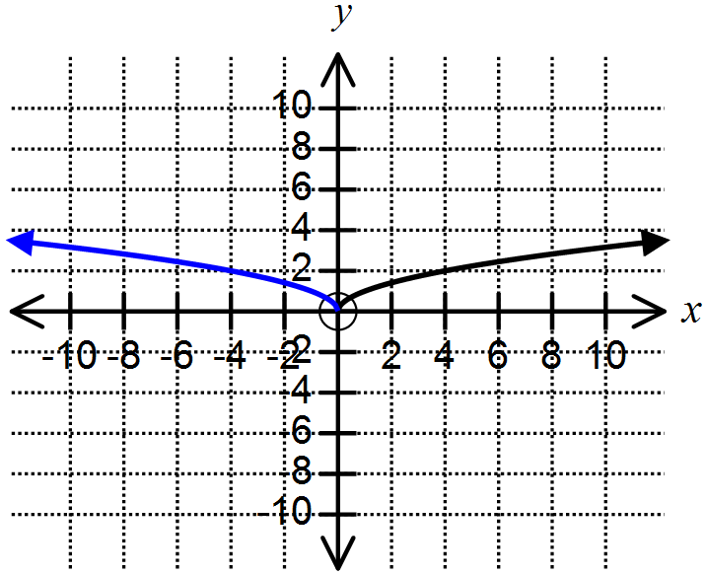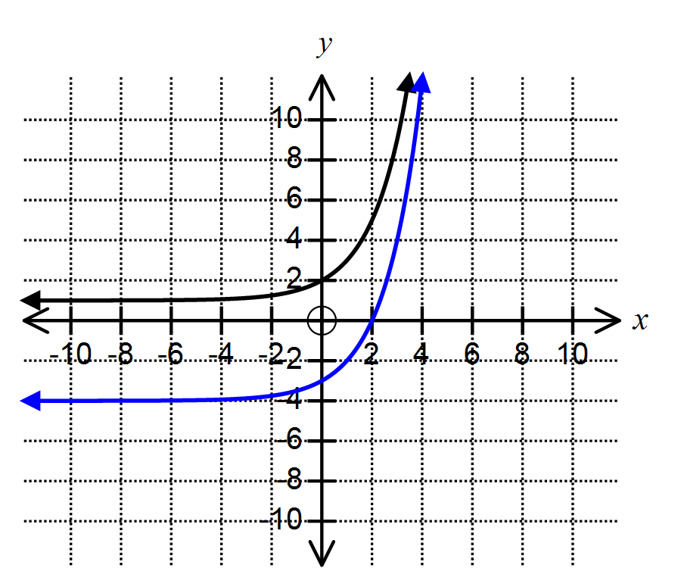

(c)

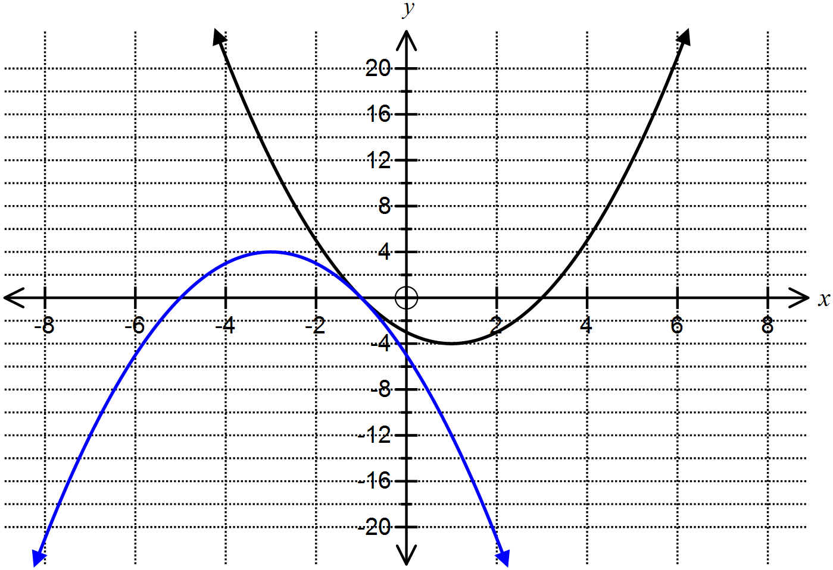

(d) (i) (ii)

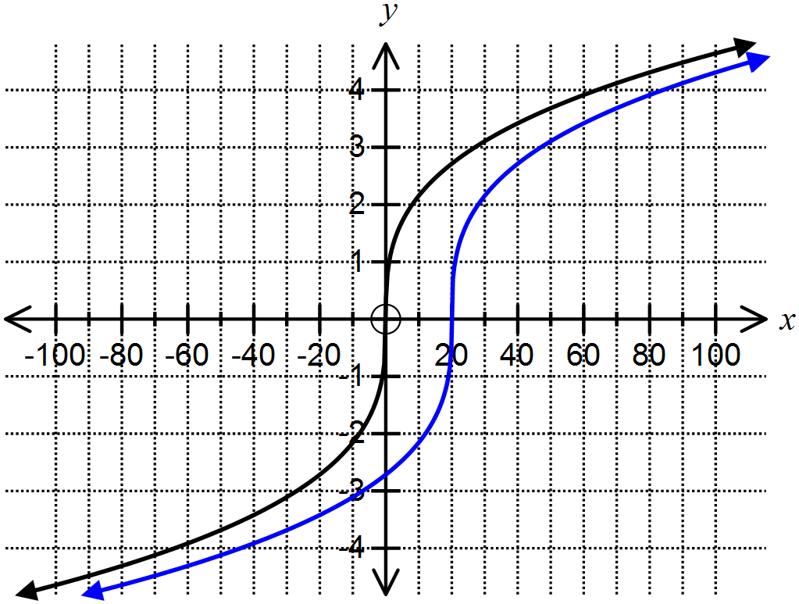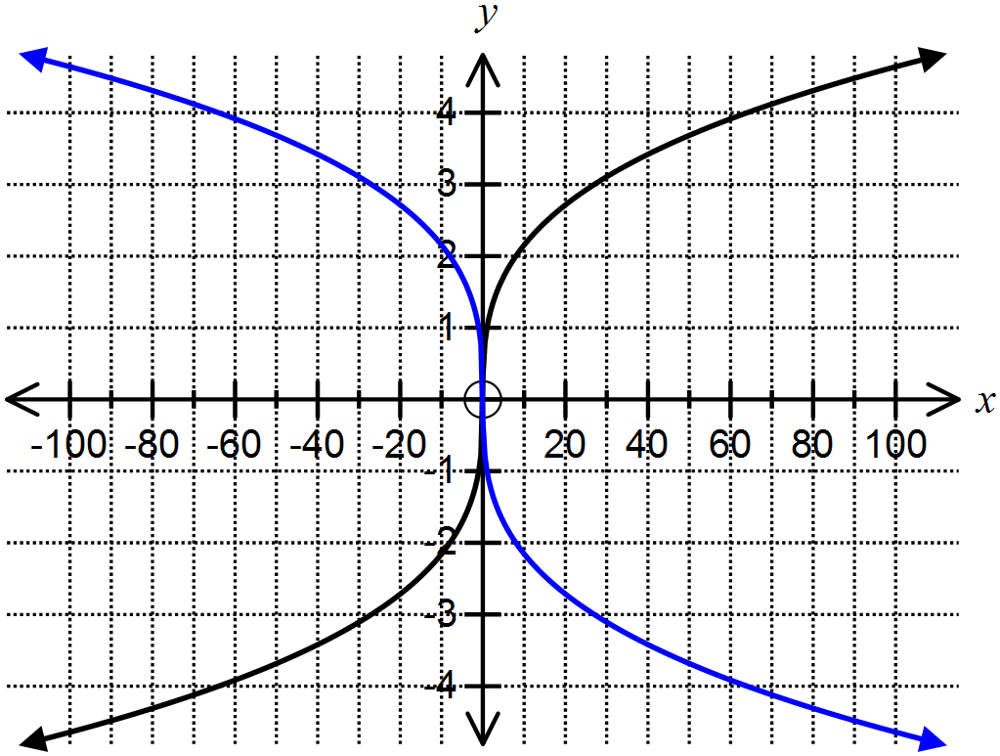

|  |  |  |  |
| --- | --- | --- | --- |
|  | **Behaviours:**  Accurately draws a graph which is… | **Marks** | **Item\***  **(S/C)** |
| (a) | translated 5 units down | 1 | S |
| (b) | reflected in the -axis | 1 | S |
| (c) | translated 4 units left  reflected over the -axis | 1  1 | S  S |
| (d) | (i) reflection in the -axis  (ii) translated 20 units to the right | 1  1 | S  S |

**Question 5 (5 marks)**

|  |  |  |  |  |
| --- | --- | --- | --- | --- |
|  | **Solution** | **Behaviours** | **Marks** | **Item\***  **(S/C)** |
| (a) |  | Recognises the need for the opposite sign | 1 | S |
| (b) |  | Adds 5 to the function provided | 1 | S |
| (c) |  | Takes 2 from *x* | 1 | S |
| (d) |  | Recognises the need for the opposite sign  Takes 5 from -3 correctly in the function | 1  1 | C  C |

**Question 6 (8 marks)**

|  |  |  |  |  |
| --- | --- | --- | --- | --- |
|  | **Solution** | **Behaviours** | **Marks** | **Item\***  **(S/C)** |
| (a) | (*-p, 0*) | Identifies correct line of symmetry  Identifies correct *x-*intercept | 1  1 | C  C |
| (b) | (*a*, 3) | Identifies correct turning point  Identifies correct line of symmetry | 1  1 | S  S |
| (c) |  | Nominates the correct -value  Nominates the correct -value | 1  1 | C  C |
| (d) |  | Nominates the correct -value  Nominates the correct -value | 1  1 | C  C |